Supplementary material

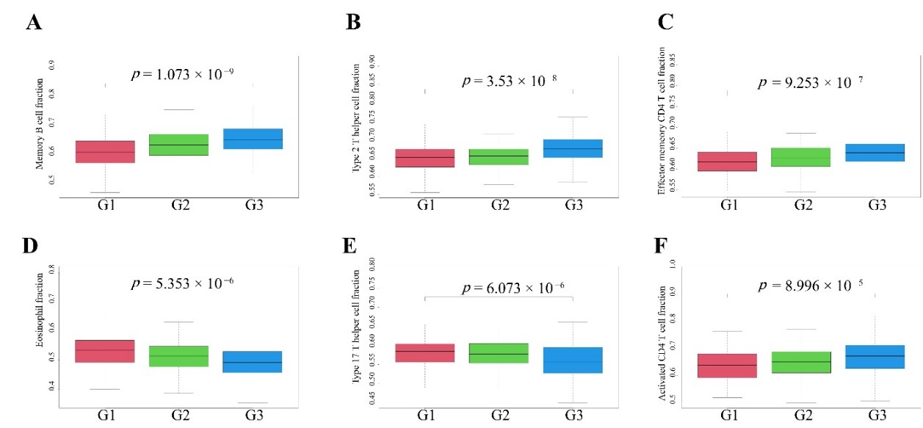
Supplementary Fig. 1. Identification and immunologic characteristics of endometrial carcinoma subtypes defined based on the immune profile. (A) Relationship between Memory B cell and pathological grade of endometrial adenocarcinoma. p = 1.073 × 10⁻⁹. (B) Relationship between Type 2 T helper cell and pathological grade of endometrial adenocarcinoma. p = 3.53 × 10⁻⁸. (C) Relationship between Effector memeory CD4 T cell and pathological grade of endometrial adenocarcinoma. p = 9.253 × 10⁻⁷. (D) Relationship between Eosinophil and pathological grade of endometrial adenocarcinoma. p = 5.353 × 10⁻⁶. (E) Relationship between Type 17 T helper cell and pathological grade of endometrial adenocarcinoma. p = 6.073 × 10⁻⁶. (F) Relationship between Activated CD4 T cell and pathological grade of endometrial adenocarcinoma. p = 8.996 × 10⁻⁵.

